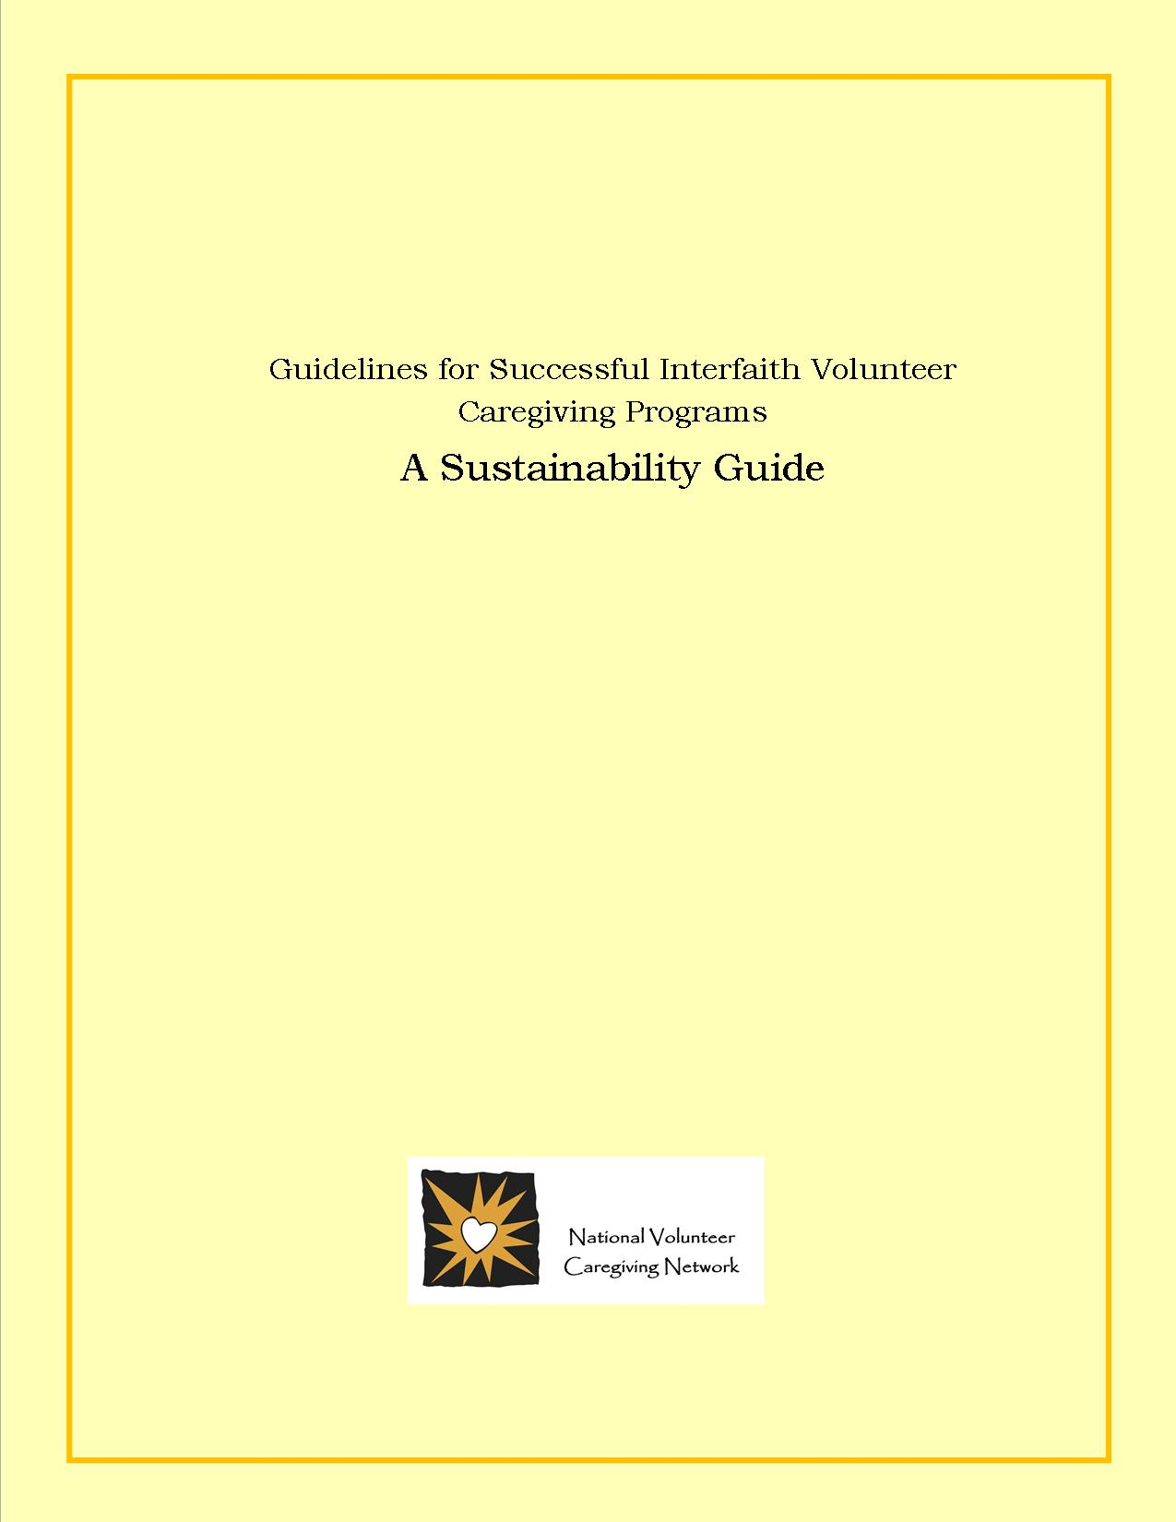

The National Volunteer Caregiving Network (NVCN) is a non-profit membership based organization that supports volunteer caregiving programs. NVCN provides this Sustainability Guide to help those concerned with the unmet needs of people living with chronic conditions to utilize in conjunction with their 2011 Start-up Guide.

This detailed Guide can be used by newly formed volunteer caregiving organizations to help ensure long-term sustainability, and as a benchmark for long existing programs. Each section of the guide outlines a critical component of the volunteer caregiving organization. NVCN maintains a resource library on the web that can and should be used in conjunction with this guide. Administrative helps, fundraising ideas, templates, position descriptions and more are at their member’s fingertips. (http://www.nvcnetwork.org)

The NVCN mission is to promote volunteer caregiving through advocacy and the support and development of local programs. This newly revised guide, originally developed by Interfaith Volunteer Caregivers (2002) helps to fulfill the mission and ultimately their vision; to have an interfaith caregiving program in every community that needs one.

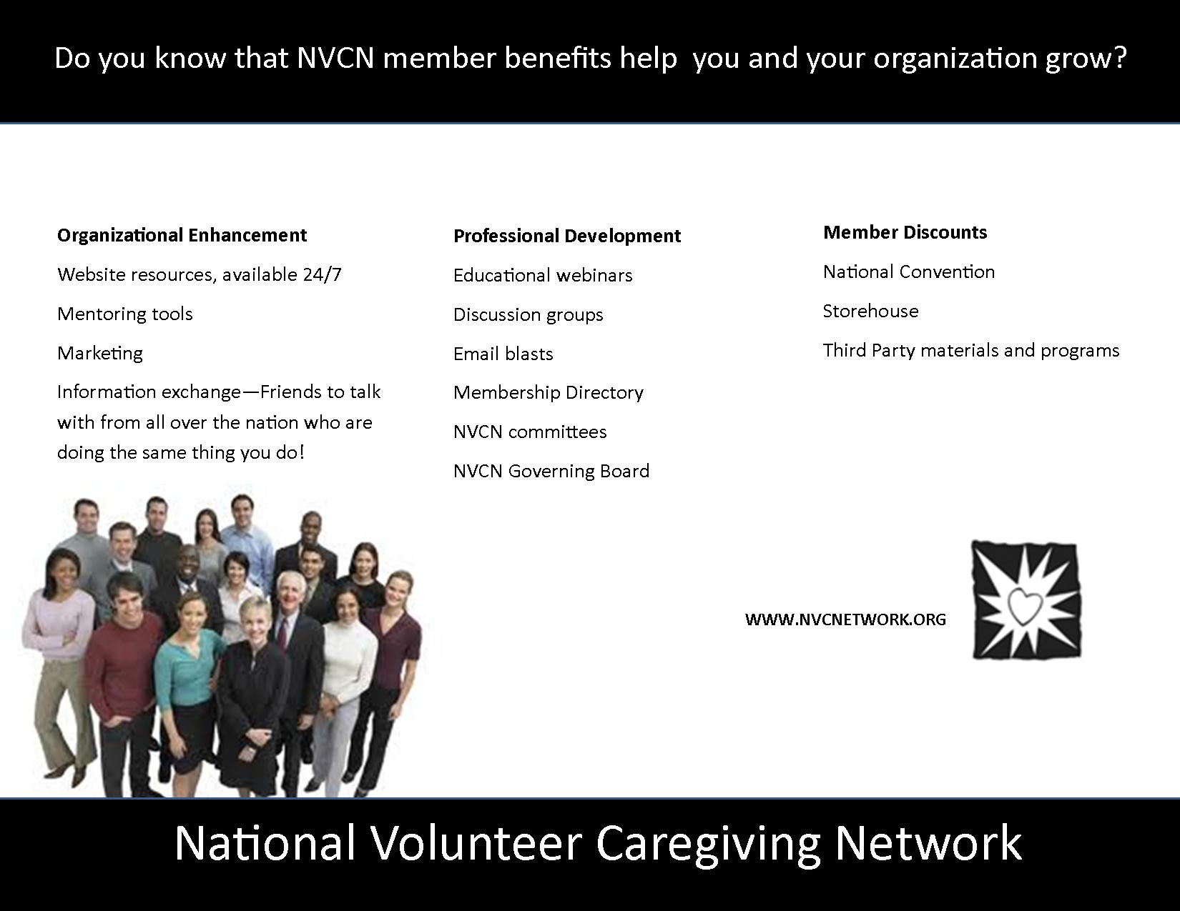

|  |  |
| --- | --- |
| 1. Structure & Function | Page 4 |
| 1. Coalition 2. Governance |  |
| 1. Mission, Strategic Planning & Performance Assessment | Page 6 |
| 1. Mission 2. Strategic Planning 3. Performance Assessment & Improvement |  |
| 1. Volunteers | Page 7 |
| 1. Planning & Recruitment 2. Screening & Placement 3. Orientation, Training & Performance Review 4. Volunteer Rights 5. Policies & Procedures |  |
| 1. Marketing & Public Relations | Page 9 |
| 1. Program Identity & Image 2. Planning 3. Documents 4. Public Education & Disclosure |  |
| 1. Fund Development | Page 10 |
| 1. Fundraising Planning 2. Fundraising, Policies, Legal Requirements & Ethical Accountability 3. Donor Rights & Relationships 4. Acknowledgement, Accounting & Reporting |  |
| 1. Administration | Page 11 |
| 1. Human Resource Management 2. Information Management 3. Financial Accountability 4. Legal Compliance & Accountability 5. Ethical Accountability |  |
| 1. Care Recipient Rights & Services | Page 13 |
| 1. Rights in Providing Services 2. Provision of Services |  |
| 1. Technology: A Mission Accelerator | Page 14 |

**Guidelines for Successful Interfaith Volunteer Caregiving Programs**

Table of Contents**Guidelines for Successful Interfaith Volunteer Caregiving Programs**

**I.** **Structure and Function**

1. Coalition

1. Composition

* The Coalition reflects the diversity of faith-based organizations as well as other organizations or agencies that have a caregiving tradition or mission in the community it serves.
* The Coalition has a detailed plan for expanding the Coalition to achieve and maintain the desired composition.

2. Roles and Responsibilities

* The Coalition works in partnership with community leaders, community organizations, and health and human service agencies.
* The organization's bylaws set forth responsibilities of the Coalition and its members.
* Coalition members are given their responsibilities in writing and provide a signature indicating their receipt and understanding of their responsibilities.
* The Coalition provides input and recommendations to the Board, but does not attempt to act as the Board.
* Coalition members participate in setting the organization's mission.
* Coalition members refer care recipients and volunteers to the Caregiving Program.
* Coalition members support the program financially and/or with in-kind contributions.
* When acting on behalf of the Coalition, members' actions and language are nonpartisan and consistent with the Coalition mission.
* Coalition meetings are held on a regularly scheduled basis, are well attended, and are managed effectively.
* Efforts are made to schedule and conduct Coalition meetings in ways that respect individual faith observances and holidays.

1. Governance

Interfaith Volunteer Caregiving Programs are either independent 501c3 charitable organizations, or are organized under the umbrella of an existing 501c3. They are either governed by an elected (or appointed) volunteer Board of Directors (if an independent 501c3) or an Advisory Board that reports to the full Board of an existing 501c3.

Either way, the Board consists of individuals who are committed to the mission of the program. The 501c3 Board has ultimate responsibility and legal authority for managing the organization and for the quality of care and services it provides. Bylaws should include provisions for election /appointment of members as well as term limits and procedures for filling vacancies as they occur.

Note: Governance applies to the organization's governing body, whether it is called a Board of Directors, Board of Trustees, or some other term. As used herein, the term Board is used to mean all governing bodies.

1. Board Composition

* The Board is composed of individuals who are personally committed to the mission of the organization.
* Board composition reflects the diversity of faith, gender, age, race, and culture found within the community.
* The Board is comprised of members of the faith community and appropriate representation from key community organizations or agencies, members with special expertise (e.g. accountants, lawyers, fundraising experts, media/communication experts), and those served by the organization, as appropriate.

2. Board Structure

* If a 501c3 needs to be created, the Board is actively pursuing it, a timeline has been established, and the assistance needed to accomplish this goal has been secured.
* Whether the program is organized as a 501c3 or is organized under another agency, it meets the legal and regulatory requirements governing non-profit organizations in the state in which it is located.
* The Board empowers task forces and committees to accomplish specific  
  tasks, with a scope of work and timelines approved by the Board.
* If a committee (or task force or working group) operates separately from the Board, at least one member of the Board serves on the group and has responsibility for reporting back to the entire Board.

3. Board Roles, Responsibilities, and Relationships

* The organization's bylaws set forth responsibilities of the Board and its members.
* Board members receive a list of responsibilities and provide a signature indicating receipt and understanding of these responsibilities.
* The Board engages in ongoing planning activities to achieve the mission of the organization. These planning activities include the setting of specific goals and objectives related to the mission as well as the processes for evaluating the success of the organization's programs toward achieving the mission.
* The Board annually approves the organization's budget and periodically assesses the organization's financial performance in relation to the budget.
* The organization has a policy regarding Board member and staff authority and responsibilities in decision-making. The policy is followed in everyday practice.
* Board members ensure that the scope and level of programs and services planned by the organization are being provided.
* The Board:
* hires or appoints a qualified individual and provides them with the appropriate authority to manage the organization's day-to-day operations
* establishes the individual's compensation
  + evaluates his or her performance
* Where the Program Director is a voting member of the Board (not recommended) policies and procedures are in place to ensure the employee is not in a position to exercise undue influence in the Board's decision-making.
* Board members serve without compensation, except for reimbursement of expenses directly related to their Board service.
* The Board meets as frequently as is necessary to adequately conduct the business of the organization. The schedule of meetings is set forth in the bylaws and is consistent with nonprofit laws in the state in which the program is organized.
* Processes are in place to ensure all Board members are made aware of how to fulfill their responsibilities, as defined by the organization, applicable laws and regulations.
* Official minutes are kept of all Board meetings. The minutes reflect the actions of the Board and they include reports of Board task forces and committees when they act in the place of the Board.
* The organization permanently retains the Board minutes, distributes them to the Board members, and makes them available for public review.
* Board members are asked to contribute to the program according to their means.

4. Board Development

* There is an established orientation process for new Board members.
* Written materials are provided to help Board members perform their role.
* Board members receive regular and timely communication about the organization's activities.
* The Board regularly assesses its own performance and takes corrective action when necessary.
* Board members periodically engage in planning and development exercises to improve Board performance.

**II. Mission, Strategic Planning & Performance Assessment**

A. Mission

* The organization's mission is formally and specifically stated and it is defined and approved by the Board with input from the Coalition, and other stakeholders.
* The mission statement is reviewed annually as part of strategic planning and program evaluation.
* The organization's activities are consistent with its stated mission.

B. Strategic Planning

* The Board participates significantly and meaningfully in a strategic planning process guided by the mission of the organization.
* A strategic plan is developed and used to guide decision-making with respect to the allocation of fiscal and human resources to meet community needs.
* The Board elicits input from all stakeholders and this input is used in the strategic planning process.
* The plan contains short and long-term goals with specific, measurable, and realistic objectives and timelines.

C. Performance Assessment and Improvement

1. The Board periodically reviews its mission and strategic plan to determine:

* If they need to be modified to reflect societal changes
* If the need for its programs continues to exist
* If its current programs should be revised or discontinued
* If new programs should be developed

2. The Board has established procedures for evaluating, both qualitatively and quantitatively, its programs and projects in relation to its mission and strategic plan.

* These procedures address program efficiency and effectiveness, and the relationship of outcomes to the cost of achieving them.
* Evaluation data are used to make changes that strengthen the program. Evaluation measures include, for example: number of volunteers, hours and types of service provided, number of care recipients served, care recipient and volunteer satisfaction measures, community and Board feedback measures, volunteer and care recipient retention rates, etc.

**III. Volunteers**

A. Volunteer Planning and Recruitment

* The program determines the requirements (skills, contacts, abilities, attitudes, availability, and levels of commitment) needed from volunteers.
* Volunteer requirements are explained in written position descriptions and recruitment materials.
* Position descriptions are developed for all types of volunteer assignments, and are shared with volunteers before they are given an assignment. The position descriptions are reviewed annually and changed if necessary.
* Position descriptions include, at a minimum, title, responsibilities, qualifications, time requirements, and supervisor contact information.
* The program develops and implements an ongoing plan for volunteer recruitment.
* Efforts are made to recruit volunteers from all sectors of the community, without regard to age, gender, race, or religion.

B. Volunteer Screening and Placement

* Volunteer applicants learn about the organization, and then review their position description and expectations to be evaluated for determining their best fit
* The program employs a Board-approved system for background checks on all volunteers (references and/or criminal checks) before they are accepted by the program.
* Screening criteria are established and applied equally to all volunteer applicants.
* Volunteers are matched with those in need; matches are made using information gathered about the volunteer during the screening and orientation process, as well as information gathered about the person needing care.

C. Volunteer Orientation, Training and Performance Review

* Before providing caregiving service, all volunteers receive an orientation given by a qualified instructor. This session informs them about:
  + The mission of the organization
  + Policies and procedures
  + Volunteer positions
  + Expectations
* All volunteers receive training from a qualified instructor to provide them with the information, skills, and tools they need to succeed at their assignments.
* Board-approved volunteer policies exist regarding:
* Treatment of care recipients and their families
* Handling of client property
* Acceptance of client funds or gifts
* Regulations regarding the driving of vehicles and transporting others
* Handling emergency medical situations
* Other relevant program policies that impact the work of the volunteer

* Verification of orientation and training for all volunteers is recorded
* Regular audits of volunteers are done for quality control
* Volunteers are given regular and ongoing feedback regarding their performance
* Volunteers have an opportunity to give feedback to their supervisor and to the organization
* Volunteers are given exit interviews when they leave the program

D. Volunteer Rights

* Volunteers are adequately informed and prepared for duties assigned.
* Volunteers are covered by liability insurance with coverage appropriate for the tasks and responsibilities they assume.
* Recognition is provided to volunteers at regular intervals in ways that are meaningful to them.
* Expectations of volunteers are clearly defined and communicated.
* Volunteers receive regular and timely communication on Caregiving activities.
* The Program keeps volunteer addresses and phone numbers on file but they are not released without permission of the volunteer.
* Needs of volunteers are identified, respected, and a fundamental consideration in the program practices.
* Volunteers are given the support they need to ensure program effectiveness.

E. Volunteer Policies and Procedures

The Caregiving Program has written and Board approved policies and procedures

* Initial volunteer assessment and screening
* Assignment to, and training for, work assignments
* Responsibilities and appropriate behaviors
* Ongoing supervision and evaluation
* Termination or reassignment .
* Filing of grievances
* Confidentiality of volunteer, care recipient, and program information
* Policies are in place to help ensure that volunteers, when acting on behalf of  
  the Program, do not proselytize, and do not use actions or language that are  
  inconsistent with the mission.
* The program's staff or volunteer leaders keep records on each volunteer
* appropriate personal information
* orientation and training completed
* evaluations
* assignments
* hours volunteered
* problems encountered
* records are maintained for a minimum of three years after the volunteer terminates service

Regular and periodic reports (detail of services) are generated and used by staff and the Board to  
analyze the Program's progress and needs related to volunteer management issues.

**IV.** **marketing & Public Relations**

1. Program Identity & Image

* The Program mission statement is concise and clearly communicates the reason the Program exists.
* Effective and timely communication vehicles are regularly used to tell the Program story, to recruit volunteers, and to inform current and prospective care recipients, donors and funders.
* Board members and senior staff participate actively in the community to bring visibility to the organization and its programs.
* Policies and procedures are in place to ensure the Program handles information with appropriate confidentiality, safety, accuracy, and integrity.

1. Planning

Comprehensive marketing plans have been developed and are being implemented.

* Communication objectives
* Message(s) for each target audience
* Community at large
* Faith Community Leadership
* Service and health care organizations
* Care recipients
* Donors
* Volunteers
* Service Clubs
* Others
* Anticipated benefits of achieving each objective
* Tasks that need to be completed, who will do them and how often/by when
* Estimated expenses
* Sources of funding

1. Documents

Written plans covering the following policies:

* Crisis management
* Media relations
* Media releases created and distributed
* Maintain and use a current list of contacts within the community
* Spokespersons have been identified, protocol established
* Press file maintained
* Public policy/advocacy
  + Represent the interest of the community it services
* Board members, staff, volunteers and constituents are encouraged to participate in public affairs
* Advocacy should be defined in order to determine policy positions
* Public Relations
* Spokespersons are qualified and trained to give effective interviews and foster  
  positive media relations.
  + Program communications regularly highlight program news, accomplishments, needs, contributions of volunteers, and thank you letters from care recipients.
  + All promotional activities are truthful, include all material facts, and make no exaggerated or misleading claims.

1. Public Education and Disclosure

* The organization has at least one staff member who is responsible for assuring that the organization is complying with federal and state laws.
* The organization prepares information about the organization's mission program activities, basic financial data, and the names of the organization's Board and management staff and makes it available to the public (usually on the organization’s web site)
* The organization's IRS Form 990 is available at the organization's offices during office hours, and copies of the 990 reports for each of the last three years are made available to anyone who requests them, and it is recommended that the last three years also be available on the organization’s web site.
* The organization provides members of the public with a meaningful opportunity to communicate with an appropriate representative of the organization, when requested.

**V. Fund Development**

Charitable fundraising provides an important source of financial support for the work of Volunteer Caregiving Programs. A fundraising program should be maintained on a foundation of truthfulness and responsible stewardship. Fundraising practices should be consistent with the **P**program’s mission, compliant with laws and regulations, compatible with its organizational capacity, and respectful of the interests of donors.

A. Fundraising Planning

A comprehensive fundraising plan has been developed that includes:

* The names of specific and general funding sources (individuals, businesses, foundations, special events support sources)
* The solicitation approach to be used for each source
* Specific responsibilities and assignments for staff and Board members
* Timelines and reporting procedures
* Fundraising costs should not exceed one third of the net raised by any method
* A case statement for Program support has been developed
* What are the program goals?
* Why is the program important and unique?
* What are the funding needs?
* How will goal attainment be measured?
* The Program's funding is diversified so that it does not rely exclusively on any one source
* The Board examines the development plan regularly and works with staff to make sure that it is being implemented on the established schedule and that goals are being achieved.
* A plan is in place to ensure required reports are submitted according to time frames set by the funding source.
* Fundraising personnel, whether employees or independent consultants, are not compensated based on a percentage of the amount raised or on the basis of another commission formula.

B.Fundraising, Policies, Legal Requirements, & Ethical Accountability

* Copies of grant reports are shared with the Board after they are submitted and kept on file by the Program staff.
* All legal requirements for raising funds in the Program’s home state have been met and for other states that might be involved.
* The Program has policies in place that govern the receipt and treatment of charitable gifts and grants:
* Individual limits or entities that will not be accepted
* Purposes for which donations will be accepted
* Type of property that will be accepted (e.g. real estate)
* The P rogram honors all statements about the use of contributions made in its fundraising appeals.

1. Donor Rights & Relationships

* The privacy of donors are safeguarded
* Donors are provided an opportunity to state that they prefer to remain anonymous
* Solicitations are free from undue influence or excessive pressure
* Donor intentions and wishes regarding donated funds are honored. If it is not possible the donor is informed and the money is returned
* Donors are acknowledged meaningfully and appropriately

D. Acknowledgments, Accounting, and Reporting

* Fundraising materials clearly identify the Program, its mission and the intended use of the solicited funds.
* There is a process in place for safely handling and accounting for all donations received.
* Donations (including in-kind contributions) are acknowledged in no more than 3-5 business days and appropriate tax documentation is provided to donors.
* The organization's annual report cites the sources and amounts of donations received, including financial equivalents of in-kind contributions.
* The annual report is distributed to donors and supporters and is posted to the Program website

**VI. Administration**

A. Human Resource Management

1. Retention, Training and Development

* The Program uses a nondiscriminatory process to recruit and select staff
* The number and qualifications of staff are adequate to meet the Program's goals and objectives.
* Staff compensation is similar to that of other positions in the community with similar educational and experiential requirements and levels of responsibility.
* New employees receive an orientation, including review of their responsibilities and personnel policies and procedures. Employees are provided with a copy of the personnel policies and/or an employee handbook. .
* The Program has a performance appraisal system in place to ensure regular evaluations of employee performance by their supervisors.

1. Personnel Policies

The program has written personnel policies and procedures, approved by the Board, governing the work and actions of all employees of the organization, including:

* Employee orientation and training
* Working conditions
* Benefits
* Evaluation
* Grievance procedures
* Confidentiality and security of employee, client, and organizational records
* Social Media policies

1. Management of Information

The Program maintains accurate and up-to-date records on:

* Coalition members
* Volunteers
* Care recipients
* Staff
* Insurance
* Vendor contracts
* Budgets
* Grants

The organization develops and implements measures to safeguard data and information against loss, destruction and tampering.

1. Financial Accountability

The Program has written financial policies governing:

* Investment of assets
* Internal control procedures (handling money, writing checks, paying bills)
* Purchasing
* Unrestricted current net assets
* The Program operates in accordance with an annual budget that has been approved by the Board prior to the fiscal year.
* Staff regularly prepares internal financial statements (at least quarterly) for the Board and identifies and explains variation between budgeted and actual revenues and expenses.
  + The Program provides employees a confidential means to report suspected financial impropriety or misuse of resources.

1. Legal Compliance and Accountability

The Board is aware of and complies with all applicable federal, state, and local laws such as:

* Fundraising
* Licensing
* Financial accountability
* Human resources
* Lobbying and political advocacy
* Taxation
* The Board reviews the Program's relationships with community partners to ensure these relationships are in compliance with applicable laws and regulations.

The Board develops and enforces a written conflict of interest policy applicable to Board members, staff, and volunteers who have significant independent decision-making authority regarding the resources of the organization. The policy:

* Identifies the types of conduct or transactions that raise conflict of interest
* Sets forth procedures for disclosure of actual or potential conflicts
* Provides for review of individual transactions by the uninvolved members of the Board.
* The Board periodically assesses the need for insurance coverage in light of the nature and extent of the Program's activities and its financial capacity.
* If the Board decides to forego general liability insurance coverage or Directors and Officers liability insurance coverage, this decision is captured in the minutes for the meeting at which the decision was made.
* The Program periodically conducts an internal review of its compliance with known existing legal, regulatory and financial reporting requirements and provides a summary of the results of the review to members of the Board.

1. Ethical Accountability

* The Program identifies potential ethical issues and develops processes to handle such issues when they arise.
* The Program trains staff and volunteers about the ethical aspects of caregiving services and about available procedures for addressing ethical issues.

**VII. Care Recipient Rights & Services**

1. Care recipient rights in providing care or services.

* Care recipients are afforded the right to make informed decisions regarding proposed and ongoing care or services.
* Care recipients are afforded the right to have complaints heard, reviewed, and if possible, resolved.
* Care recipients are afforded the right to confidentiality of information.
* Care recipients are afforded the right to privacy and security of themselves and their property.
* Care recipients are informed of their rights in writing and in a manner in which they understand.

1. Provision of Care & Services

* The Program only offers services that its volunteers can appropriately and safely provide.
* The Program only serves those who have identified care needs that can be adequately and safely met by the services it provides.
* The Program asks care recipients to sign a hold harmless agreement.
* When the Program provides more than one service to the care recipient, the individual services are coordinated.
* The Program notifies the care recipient of any significant changes in the agreed-upon schedule of care or services.
* The Program's staff has access to information on community resources and refers carerecipients appropriately to other service organizations.
* The Program coordinates its care or services with other involved organizations so that there is no duplication or conflicts of service.

**VIII. TECHNOLOGY: A MISSION ACCELORATOR**

The use of technology as a mission accelerator is an absolute must for organizations that wish to provide the best services and to remain sustainable. A written technology plan should be in place; the Program should consider the following list.

* Computers with the latest technology and software are available for each staff member
* High speed Internet capability and email services are installed
* A maintained Website that can be readily found
* Accounting software, Donor Software, Customer Management Software
* Technology is a must if you want to recruit staff and volunteers under 30
* Tech planning – tech soup.org offers many resources to help, including sample requests for proposal (RFP)
* What is our core mission, and how will this investment improve our ability to carry out that mission?
* What do you see as the most pressing needs for your organization that technology might address?
* Who at the agency has been involved in planning for technology staffing, training and purchases?
* Who at the agency has been involved in day-to-day computer troubleshooting and maintenance tasks?
* Who will be involved in the implementation of new technology efforts?
* Are staff members able to use the technology that is crucial to their efficiency and to the tasks they need to accomplish?
* What type of financial resources does your organization have available for technology?
* What are the obstacles to your organization’s effective use of technology?
* Do you need better systems to streamline your operations, increase communication among staff, reach out to clients, cultivate your Board, or communicate with your members?
* What role does the implementation of new technologies play in your strategy for the next five years? Would new technology allow you to respond to new opportunities?
* Consider social media sites such as Facebook, Linked in, Twitter, U-Tube, etc
* Blogs

