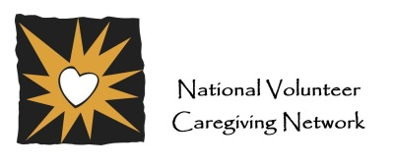
Contact: 304.907.0428, info@nvcnetwork.org; www.ncvnetwork.org

NOTE: Remember to print the cover letter on your original letterhead and handwrite the signature on each letter.

Date

Recipient’s name
and address

Dear Ms./Mr. (Insert last name) ,

(Insert name of program) is very interested in hearing your opinions about ________________________________. Attached you will find a short survey. We would appreciate it if you could take the time to complete it and return it to us by _________________. Your answers and comments will be crucial in helping us understand what we do well and what we need to improve in/with ____________________________________. The more people who respond, the more the results will accurately represent the views of our __________.

Completing the survey would take _____ minutes of your time. After completing it, please put it in the enclosed self-addressed, stamped envelope and mail it.

You have been selected to participate because ________________________________________.
Responses will be completely anonymous; your name will not appear anywhere on the survey. All of the information you provide will be kept confidential and will be presented only in an overall summary. You will not be identified in any survey results. Your participation in helping us with this survey is completely voluntary.

If you have questions about the survey, please feel free to contact me at (insert phone number) or (insert email address).

Thank you for your time and effort in helping us with this important project!

Sincerely,
(Insert name)

