Volunteer Survey Summary 2012

**Staff is friendly**

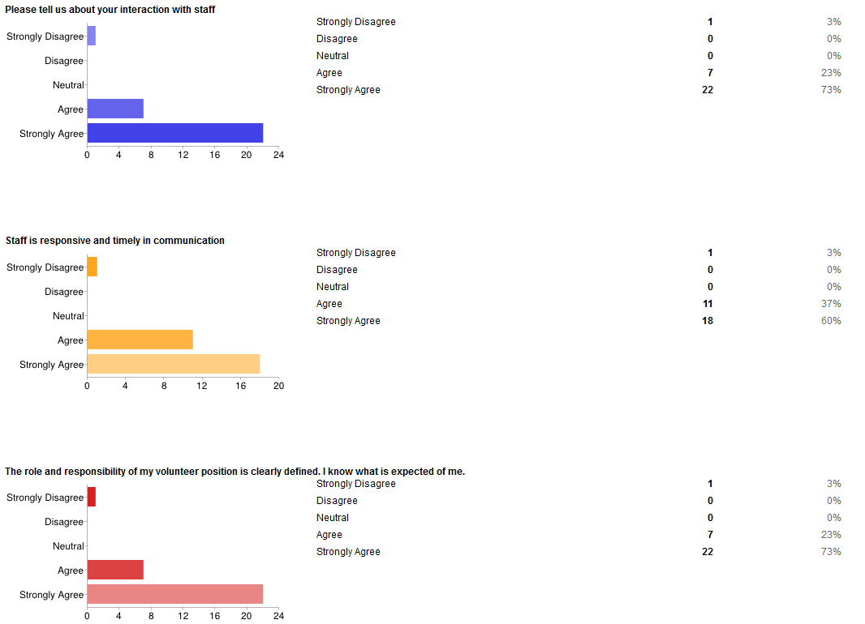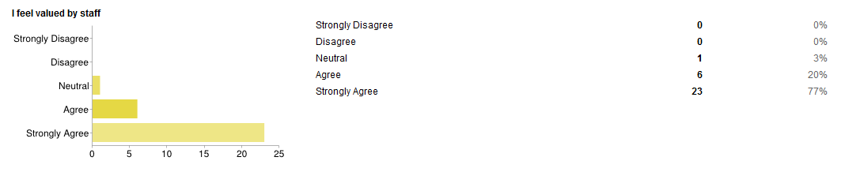

**Comments:**

"They are all saints. You couldn't find a more dedicated, caring, efficient bunch of folks. And they all have a great sense of humor, too.

A great, all-around team!

"I think we have the best staff in the world. They show caring and concern. We couldn't do any better."

In assigning my driving assignment, they are very cooperative getting the need to fit my availability.

Margie is a great communicator and very knowledgeable about each of the clients. Love working with her! She is an asset to EFS.

An awesome staff!

Always appreciative of my volunteering; very friendly, very efficient in getting back to my requests, questions, etc.

This is a great organization

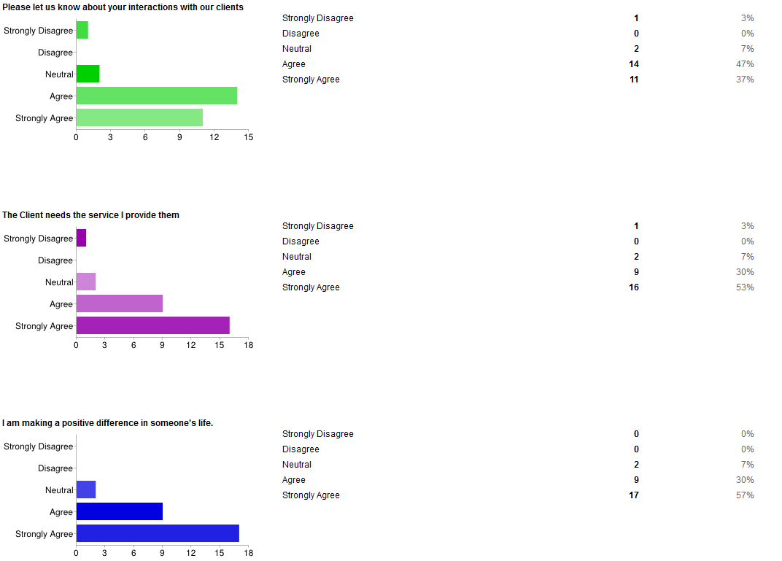

It should be made more clear to the clients that they do not pay for gas and that the actual volunteer does. Not the organization and not the client.

Clients are not always courteous and friendly. They have their moments! current client is easily confused and frustrated over seemingly minor issues and can get a bit cantankerous. I've learned to just agree and move on.

As always, there are those who "take advantage" of our service because it is there, and we are way more fun to deal with than the King County Access Van system and its drivers. Just do what you can to verify the client's situation and actual need. I'll always be a cheerful driver.

I will repeat what I tell everyone: No matter how tired or sick these folks are, they are always effusive in their thanks at the end of the ride.

They almost always thank me specifically, often profusely.

Most of the clients are so grateful for the services we offer. I hear all the time. They tell me - they don't know what they would do without it.

Appreciation is expressed on every drive I have done. Sometimes they share their cause for not being able to drive themselves, sometimes not.

there are a few that are negative but I just try to kill them with kindness and they seem to have a better attitude.

A source of inspiration!

It is always enjoyable for me to meet them and visit with them while driving them to appointments.

Almost all of the clients are thankful about the help they receive.

**Clients are courteous and friendly**

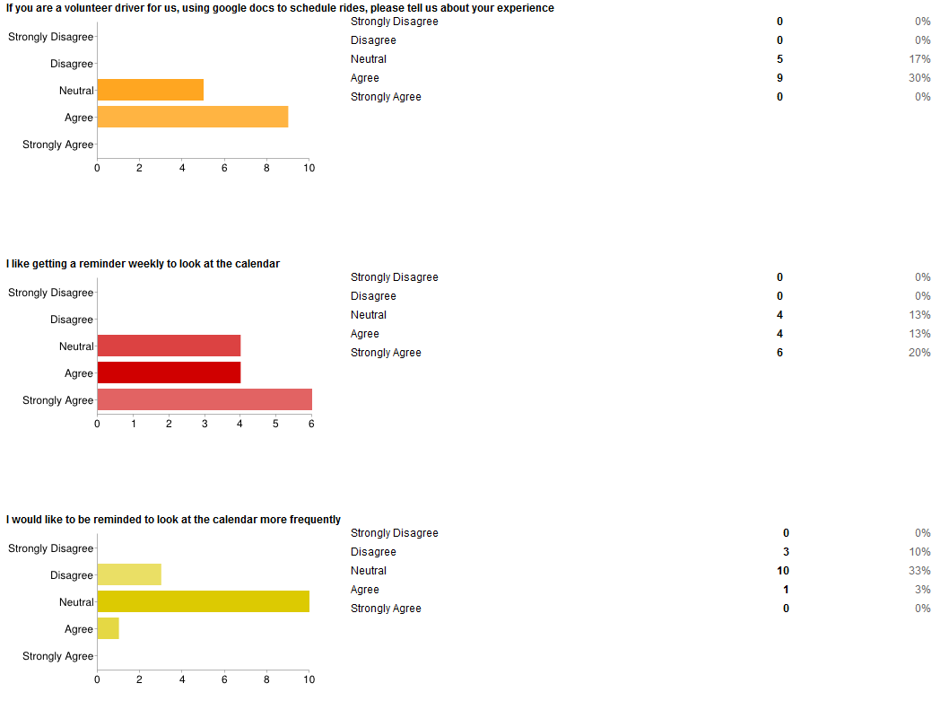

**I like using the Ride Calendar on Google Docs**

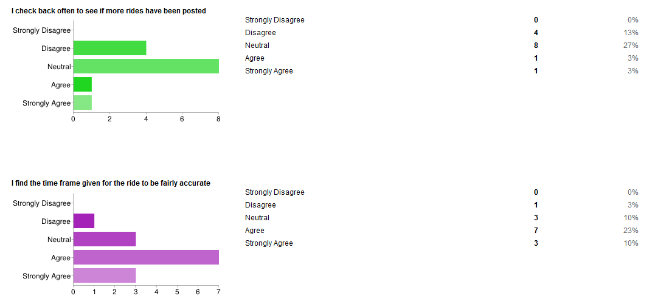

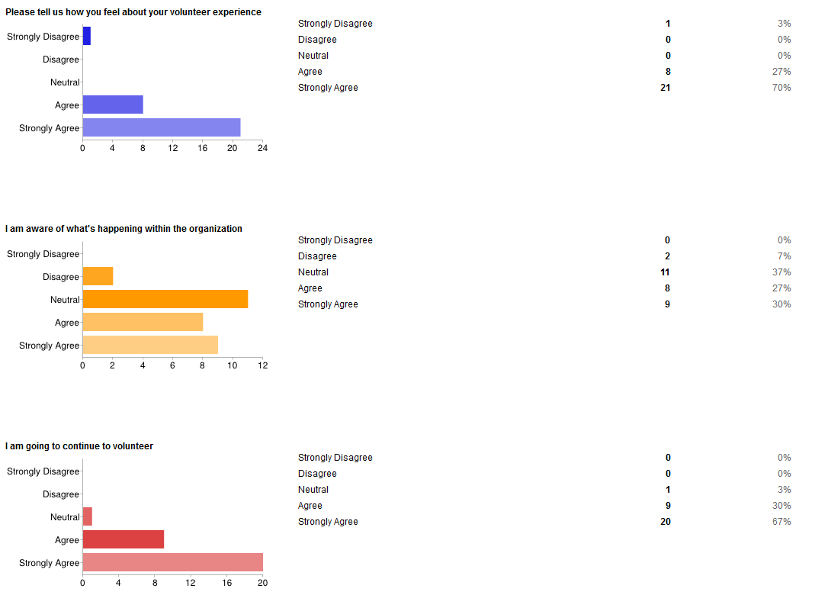

**I feel I understand the mission of Eastside Friends of Seniors**

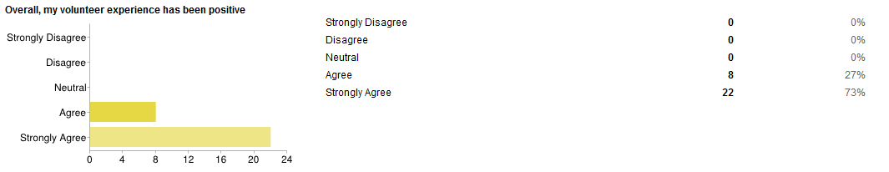

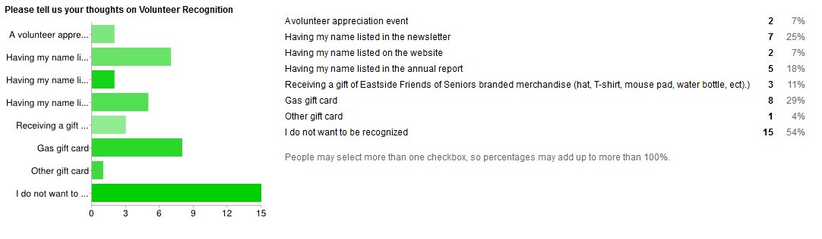

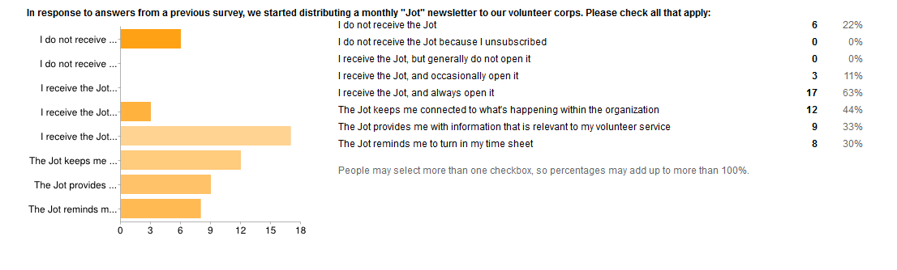

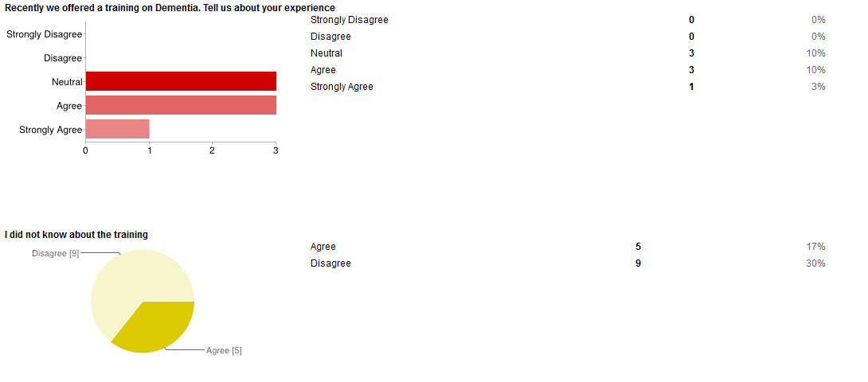

**Additional Comments:**

It's the best volunteering experience I've ever had!

Sometimes challenging but always rewarding.

Highly enjoyable, in spite of the occasional client who could be using other options just as well.

Valuable valuable experience. Volunteering is so rewarding and I learn so much plus I get to have a another wonderful relationship in my life. And I know I am making a positive difference in my client's life.

I love what I am doing and find it very satisfying.

I feel it is a gift to me to be able to do this.

Clients, volunteers, and staff provide an opportunity to be engaged in contributing to person's wellbeing, and to the community.

This has been so rewarding to me and I feel it is a helpful service to the clients and their families. I have a 25 min. drive from my house to the clients' neighborhoods so I do not drive as much as I would if I was closer.

I have formed a new friendship that I will cherish forever!

Great Staff