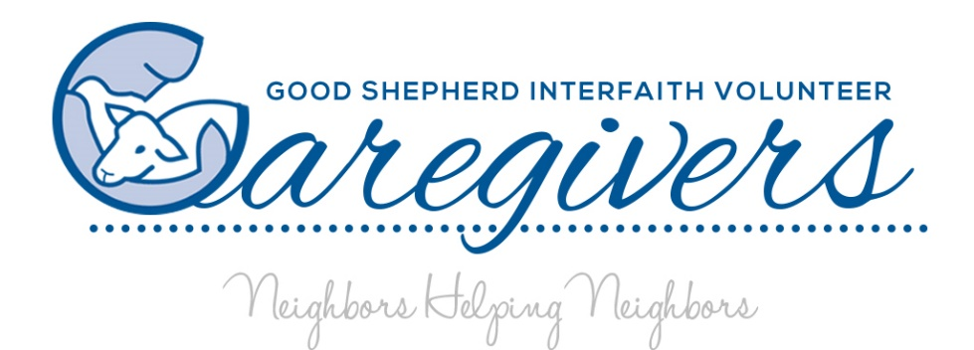

P.O. Box 1882 ◆ 7311 Martinsburg Pike ◆ Shepherdstown, WV 25443 ◆ 304-876-3325 ◆ [www.gsivc.org](http://www.gsivc.org)

In Loving Memory

Dear Friends,

Each year we appeal to you to think of our neighbors supported by your donations and the work of Good Shepherd Caregivers.

As I begin this writing my thoughts reflected on all that has occurred over the last year and contemplating what the next few months will behold. Some have lost much; work, money, loved ones, faith, hope, and health. Many did not have much to loose and now have even less than before.

My own journey of loss reminds me to remember those that struggle to make it from day to day especially when they want to give up. The extreme sadness born out of loneliness complicates everything else in their lives especially their health and wellbeing.

Then there are those that bring comfort to the suffering and pain from loss; a kind word, a smile, a phone call, a ride to the doctor, all distract and give a moment of relief. Those moments add up and help us brave another hour and another day.

We may not be able to give someone what he or she longs for, but we can give him or her a moment of peace as we say, “Yes I will help”**.**

That’s what your donations do! Thank you for supporting this appeal and your willingness to add peace to the life of another.

We are pleased to offer Neighborhood Investment Program credits. Let us know if we can reserve any in your name or in the memory of your loved one.

Blessings,

Paula Marrone-Reese

Mission: Our mission at Good Shepherd is to enhance independence, dignity, security and quality of life among the homebound, regardless of age, income or family situation by matching volunteers to fill requested services. To create a stronger, more caring community by mobilizing resources and support from faith congregations and the wider community. To reach out to our neighbors in need, filling the gaps left by formal support services.