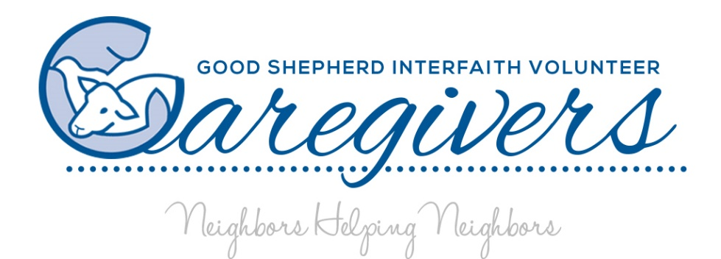

P.O. Box 1882 ◆ 7311 Martinsburg Pike ◆ Shepherdstown, WV 25443 ◆ 304-876-3325 ◆ [www.gsivc.org](http://www.gsivc.org)

2018 West Virginia Program of Excellence Award ◆ 2018 Volunteer Caregiver Network National Award of Excellence ◆ 2021 Chamber Non-Profit of the Year

Lasting Value

Dear Friends,

This year Good Shepherd Caregivers was the recipient of the *2021 Berkeley County Chamber of Commerce Non-Profit of the Year* *Award*. Dedicated to our mission and joined by loyal volunteers, we persevered while Good Shepherd was at the helm providing free services to older adults and those living with disabilities.

What a year it’s been with calls increasing weekly. Callers pleading for help, frightened by their isolation and from living without any other support. Weekly abundant calls concerning medical needs that require follow-up appointments and medical equipment, sickness that results in further treatment, loss of former transportation due to COVID. Care-receivers who have suffered loss of housing and those who require a greater degree of care were scared and helpless.

Our volunteers and staff remained faithful and flexible, while also adapting to best practices for providing services during a constantly changing time.

Sometimes the need for service arises first, and sometimes the answer precedes the need. A kind, local gentlemen had a stair lift that was no longer needed. A few weeks later, a family came forward with a request. The Dad had broken his back. Additionally the Grandmother had just moved in after a hip replacement and now required assistance. The chair lift was removed from the donor’s home and placed in the home of those who now needed this piece of equipment.

**There is lasting value in supporting our neighbors in need and lending a hand.**

Through your generosity we continue delivering services to the older adults and those living with disabilities. Won’t you consider making a gift today to continue our good work? Your gifts are meaningful and provide the fuel that makes all services possible.

Once again we offer Neighborhood Investment Tax Credits for donations of $500 or more. Please let KC Brewster or I know if you have any questions and if they are of interest to you.

Blessings,

Paula Marrone-Reese