Google Forms Instructions and Guidelines
Links for editing and analyzing surveys
English Volunteer Survey:
[Insert editable link here]
English Client/Elder Survey:
[Insert editable link here]
Spanish Volunteer Survey:
[Insert editable link here]
Spanish Client/Elder Survey:
[Insert editable link here]

Links to send for people to fill out the surveys
English Volunteer Survey:
[Insert shareable link here]
English Client/Elder Survey:
[Insert shareable link here]
Spanish Volunteer Survey:
[Insert shareable link here]
Spanish Client/Elder Survey:
[Insert shareable link here]

Upon opening the editable survey, there will be 3 tabs at the top center of your screen.
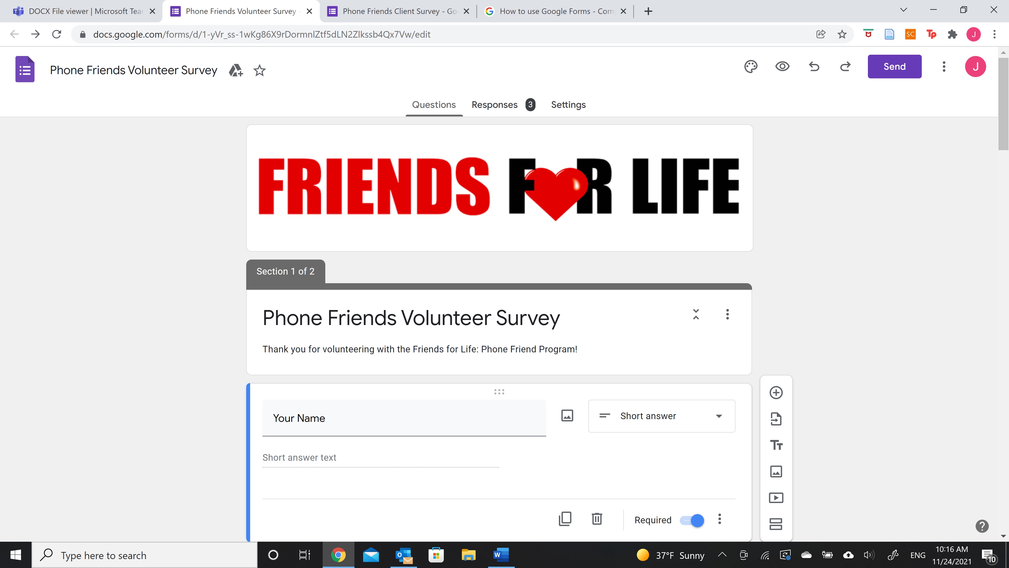

Questions Tab
Here, you will be able to:
- Add/remove questions
  - You are also able to edit question types (short answer, multiple choice), and if they are required or not
- Add/remove images and videos
- Add/remove sections and descriptions

Responses Tab
This will likely be the most used and relevant tab, with 3 extra subsections.
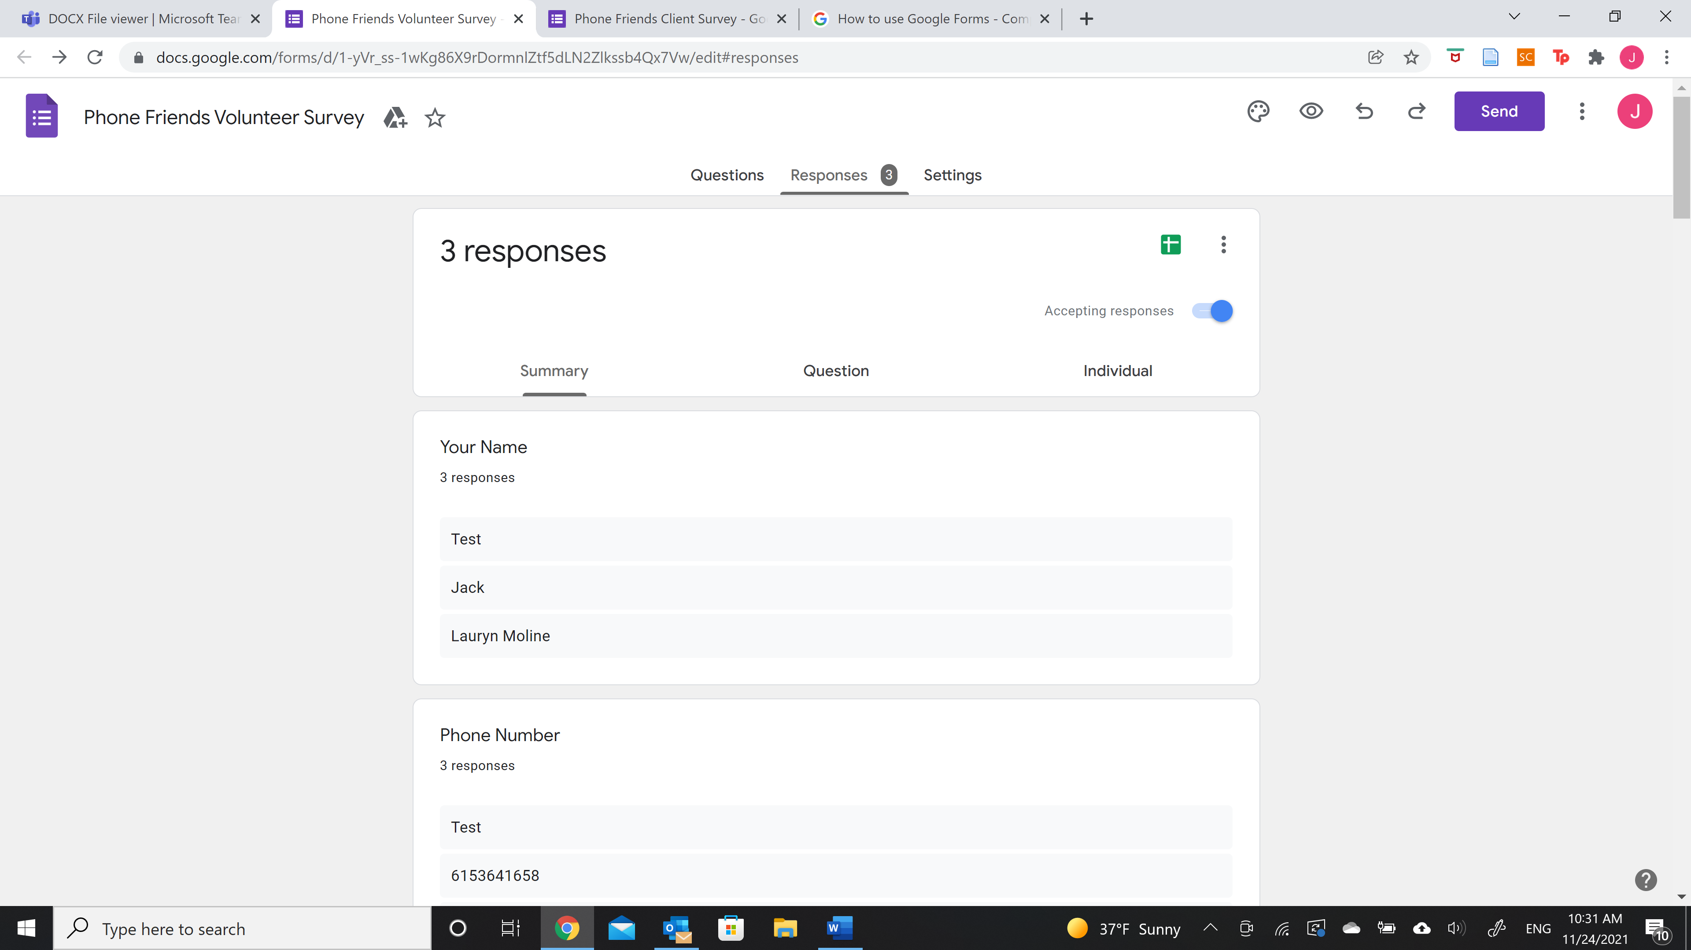*Link to open the responses in excel sheet form
Under the Summary section, you will be able to:
- View the names and phone numbers of who responded
- View charts and graphs that summarize the responses

Under the Question section, you will be able to:
- View the responses for each individual question
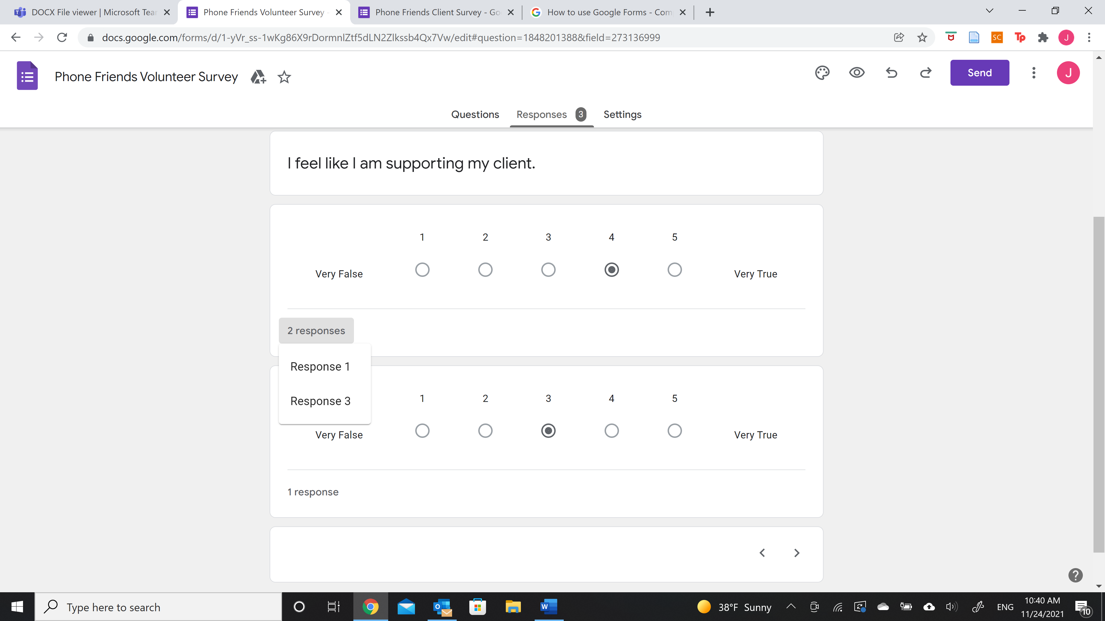
- Select the circled tab under each question answer type to view who answered that way
- By clicking on the specific response (Ex. Response 3), you will be taken to that specific individual’s response to the entire survey.
Under the Individual section, you will be able to:
- Cycle through each response to the survey to discover who sent it in.
*For example, the Question section will let you know that “2 responses” chose a “4” for a certain question. Opening “2 responses” tab will tell you which response gave that answer, but not the identification of who gave that response. The Individual section will allow you to then identify who sent the response in.

Settings Tab
Here, you will be able to:
- Edit the presentation of the survey
- Edit the response collection of the survey

*Upon first opening the forms, they will offer a “Tour” to learn how to use them. If you are not offered this option or would like to take the “Tour” again, there is a 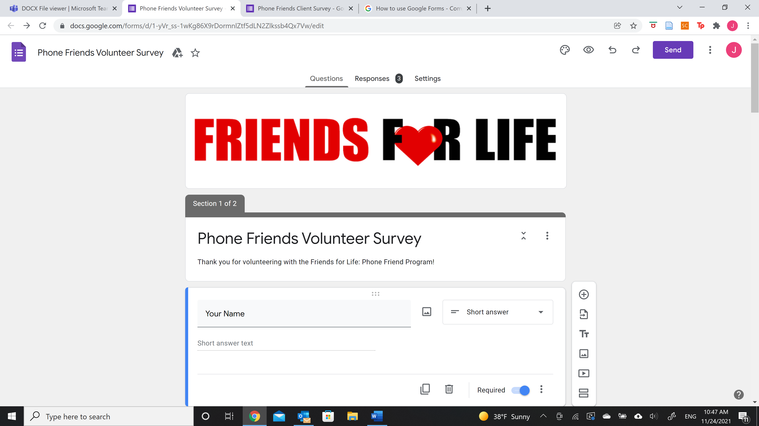 at the bottom right of your screen to take it again.

Instructions for Conducting the Client/Elder Survey:
As some of the clients have limited access or expertise to fill out the online survey, the client survey should be conducted over the phone by a volunteer or staff member who is not their Phone Friend to ensure honest answers.
1.) Open the Client/Elder Survey in the language best suited for the client:
English: https://forms.gle/DcendsCXfXxrHta86
Spanish: https://forms.gle/cMbHQqHXNYUXANbi7
2.) Before you call, fill out the survey with the client’s name and phone number. If you know the name of the Phone Friend that calls them, fill that out as well.
3.) When you begin the call, share that you are a FFL volunteer and confirm you are speaking with the right person.
4.) Ask them the questions over the phone and fill in their responses on the form.
5.) If the client has any other notes, or if you have anything that you want to note, add that to the open-ended question at the end of the survey.

UCLA Loneliness Scale Citation (Note: Scoring was modified to fit Friends for Life (Waco, TX) Survey)
https://www.ncbi.nlm.nih.gov/pmc/articles/PMC2394670/pdf/nihms47842.pdf

Additional Information:
*Using the forms should be simple enough with this Instructions and Guidelines sheet and the “Tour”, but we are happy to answer any further questions left unanswered to the best of our ability. Just send us an email!
Jasmine Hartman Budnik: jasmine_hartmanbudn1@baylor.edu

