November 1, 2011

***Dear Faith in Action Friend,***

As we reflect on our service to the seniors in our community this past year, we are thankful for the many blessings that God has given us. You are at the top of our list! Your willingness to give your support to this ministry – whether it is time or money -- has helped over **350** seniors to maintain their independence and their **HOPE**. That is a precious gift, **HOPE**, which many of our senior neighbors had not received until Faith in Action came into their lives through YOU!

***We Truly Enjoy Having You As a Member of our Faith In Action Family!!!***

You are having a direct, meaningful impact on the lives of our care receivers. It is so exciting and humbling to see this ministry making such important contributions to people’s lives.

We have seen an increase in the number of people who are asking for our help. Let’s be honest, our population is aging and we want to be there to fulfill that need. Faith in Action can only do that if the wonderful people of this community provide ***local funding*** to keep it strong. ***We do not receive any federal, state, or United Way funding.*** We are truly a local program with local support from friends like you who value what we offer in quality of life for the seniors of Bloomington-Normal.

***Help us keep Faith In Action in the Bloomington-Normal Community.***

We are so grateful for your gifts of time and talents. This year in particular, we are asking you to stand with us and make a financial donation to sustain our ministry. Perhaps you want to honor the memory of a loved one or honor a family member as you “pay it forward” so someone else can benefit from our program. For whatever reason you choose to give, we appreciate your help to keep Faith in Action meeting the needs of our senior neighbors. Please fill out the enclosed donor information and bless us with your support.

Thank you so much for choosing to be a friend of Faith in Action. With your continued support, we will keep this interfaith ministry alive and growing for the people of God in this wonderful community.

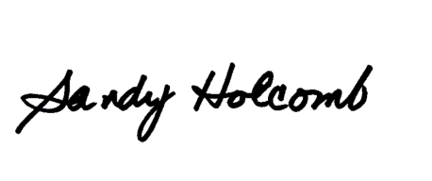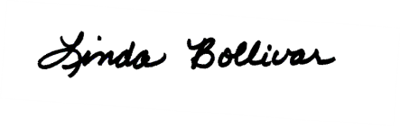

Linda Bollivar, Director Sandy Holcomb, Board President