

**VOLUNTEER**

**ORIENTATION MANUAL**

321 Wyandotte Street

Bethlehem, PA 18015

610-867-2177

(Phone and Fax)

[www.sharecarefaithinaction.org](http://www.sharecarefaithinaction.org)

[sharecarefia@aol.com](mailto:sharecarefia@aol.com)

**Table of Contents: Page**

* History of ShareCare 3
* Volunteer Protection Act 4
* Volunteer Service Insurance 5
* Confidentiality 7
* Ethics Policy 8
* Emergency Procedures 12
* Checklist of Red Flags 13
* General Volunteer Guidelines 14
* Job Descriptions 16
* Drivers 16
  + - Accident Report Form 17
    - Driver Safety Checklist 18
    - Mileage Reimbursement Program 19
* Shopper 20
* Yard Worker / Telephone Reassurance 21
* Repair Worker 22
* Visitor/Respite Care Companion 22
* Communication / Listening Guidelines 23
* Sample Monthly Time Sheet 26

ShareCare Faith In Action History

In 1990 a group of people gathered to form an organization that would provide trained, short-term volunteer relief to caregivers of the elderly in their homes so that the caregivers could get out for shopping, etc for a couple of hours from time to time.

In January 1991 In Home Respite Care, Inc. filed the necessary paperwork to become a 501c3 nonprofit organization and in November 1991 it became official. Early in 1991, Dr. Betty McMahon became the program coordinator of the organization and was viewed as the person with the vision that assisted ShareCare through its successes. Dr. Betty McMahon became the first executive director of In Home Respite Care Inc. in 1992. Louan Lukens was hired as her assistant.

The Founding Funders, Mrs. Priscilla Payne Hurd and the Cathedral Church of the Nativity, gave seed money in the 1990’s to pursue the idea. Both, Mrs. Hurd and The Cathedral Church of the Nativity, have been supporters of ShareCare since its onset.

Dr. Betty McMahon left in 1992 and Louan Lukens became the second executive director of In Home Respite Care, Inc. and hired Jill Rothrock as her assistant. One of Jill’s responsibilities was to coordinate the Adapt a Grandparent program. During 1995, calls were being received from people who needed services such as transportation to doctor appointments, light housekeeping and other chores. The Board and Louan wrote a grant to the Robert Wood Johnson Foundation (Faith in Action) for funds to provide expanded services to the elderly and perhaps the disabled in the community. The grant was awarded in 1996 to cover expanded services to the Bethlehem area with the expectation that other communities will follow suit in the future. On October 1, 1996, In Home Respite Care was renamed to ShareCare Interfaith Volunteer Caregivers of the Lehigh Valley. ShareCare began following the Interfaith Volunteer Caregivers model of recruiting volunteers from faith communities and the community at large to serve people who are elderly and/or disabled.

The founding faith communities are listed below:

Cathedral Church of the Nativity Concordia Lutheran Church

Edgeboro Moravian Church First Presbyterian Church of Bethlehem

College Hill Moravian Church Wesley United Methodist Church

Messiah Lutheran Church Christ Church UCC in Bethlehem

In 1997, Lynn Marie Heiney became the 3rd director of ShareCare. The board and Lynn decided to hire a Director of Development to help with grant writing and fundraisers. Diane Nolan was hired.

BenefitsCheckUp was a partnership developed by the United Way along with two other partners, Jewish Family Service and RSVP. Cheryl Wilson was hired as a Coordinator in 2006 and in 2008 Laura Rowe became the Coordinator. This partnership ended in December 2010, however, ShareCare continues to share resources with the partners.

In 2008 Cheryl Wilson and Kevin Moyzan were hired as Program Coordinators for ShareCare’s transportation program. The positions were funded by United Way of the Greater Lehigh Valley and LANTA (New Freedom’s Grant).

The 20th Anniversary was celebrated in 2011. It has been 20 years of serving the community and helping the elderly and those with disabilities to remain independent in their homes. With the help of our volunteers and our supporters we will be able to give another 20 years of service to our community.

Volunteer Protection Act of 1997

In 1997, a law was signed into effect to protect Volunteers from being sued by those they were helping. The law states that if any harm is caused by an act or omission of the volunteer while they are acting within the scope of his or her responsibilities as a volunteer on behalf of a non-profit organization, then they are not personally liable. A volunteer is someone who does not accept money for their work.

The following criteria must be met:

1. The volunteer was acting within the scope of his or her responsibilities in the nonprofit organization at the time of the act or omission.
2. The volunteer must have been properly licensed, certified or authorized to perform the activities but only if such license, certification or authorization is required in order to undertake the activity. (In other words if you are doing electrical work, you need to be a licensed electrician.)
3. The harm was not caused by willful or criminal misconduct, gross negligence, reckless misconduct, or a conscious, flagrant indifference to the rights or safety of the individual harmed by the volunteer. (If you choose to harm someone on purpose.)
4. The harm was not caused by the volunteer's operation of a motor vehicle, vessel or other vehicle for which the State requires an operator's license or insurance coverage. (ShareCare has supplemental driver's insurance and the volunteer's driving insurance would cover them as well.)

Exceptions to Limitations on Volunteer Liability:

The volunteer may still be held personally liable for any misconduct that:

1. Constitutes a crime of violence or an act of international terrorism and result in a conviction in any court.
2. Constitutes a hate crime.
3. Involves a sexual offense resulting in a conviction in any court.
4. Has been found to violate a Federal or State civil rights law.
5. Occurred while the volunteer was under the influence of intoxicating alcohol or any drug at the time of the misconduct.

If you want to read the full legal document please visit this government website:

http://www.doi.ne.gov/shiip/volunteer/pl_105.19.pdf

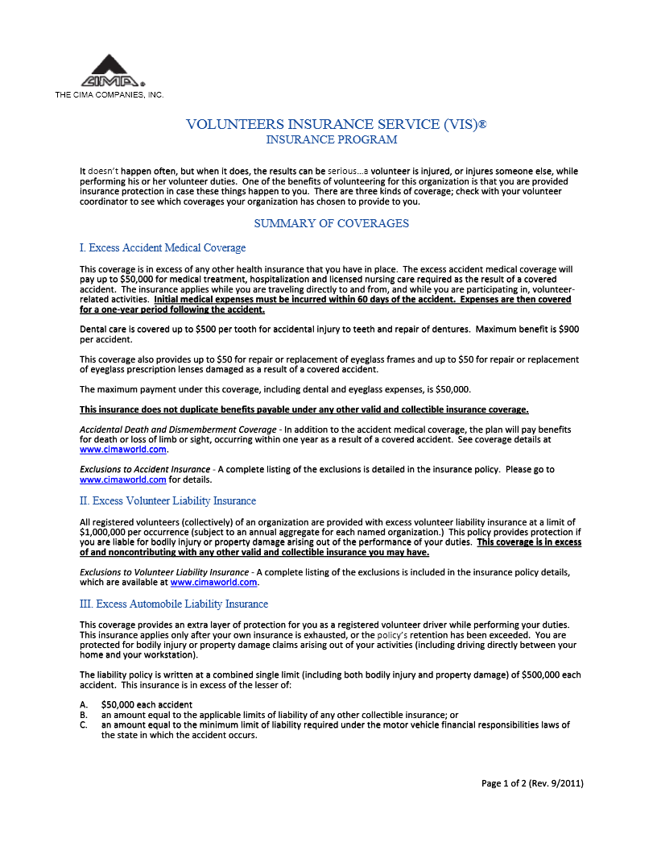

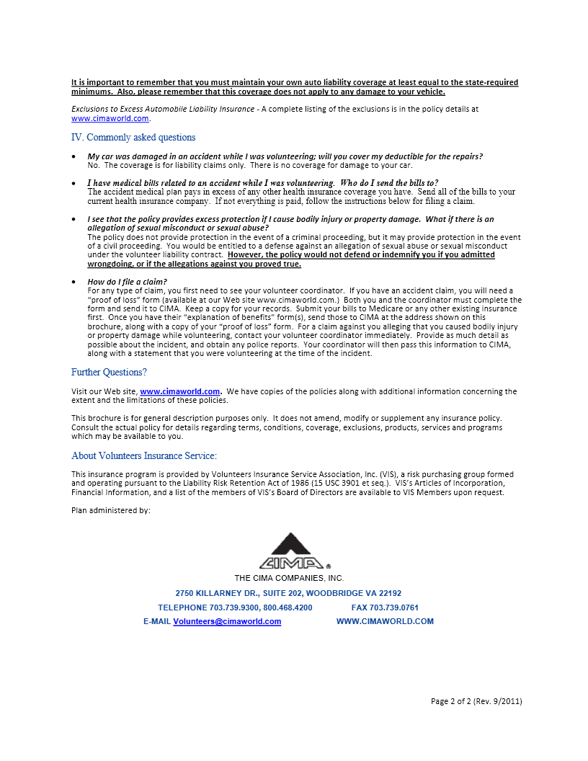

CONFIDENTIALITY

**Protecting the Privacy of Those We Serve**

ShareCare Faith In Action is dependent on a climate of mutual caring and trust. To promote this trust which exists between the volunteer and the care receiver, we must make proper use of the personal information we are given, as well as being careful not to needlessly discuss the situations we find in their homes.

When a person comes to ShareCare for assistance, personal information is often shared so we can know what type of help is needed. Information such as income, medical problems and age can be a source of embarrassment to many people. A volunteer goes into a person’s home and they observe their lifestyles, belongings and family situations, all of which is personal information.

In order to maintain the trust shown to us by their requests for assistance, we must strive to guard the dignity and privacy of everyone we serve. Personal information should not be shared.

**The Care Receiver’s Family – and YOU.**

On occasion it may seem to you that family members of our care receivers could do more for their loved one. We ask you not to make that judgment. Careful consideration of family support is given at the time of assessment so that we are not taken advantage of. Even the most supportive families often need just a little extra help to keep them from being burned out. (Remember the statistic? Thirty percent of all people in nursing homes are there because the families could no longer cope!)

We caution you also not to take sides between family members. There is much we do not know about their relationships. Families have been together a long time. Each one is different. Some are under more stress than others and all react differently. Keep an open and non-judgmental mind. Your Congregational Coordinator and/or the ShareCare director are available to help when necessary.

If you suspect there is any indication that there is any form of abuse, please contact the ShareCare office immediately. The abuse could include physical, mental, or financial.

**ETHICS POLICY OF**

**ShareCare Faith in Action**

The highest standard of ethical conduct and fair dealing is expected of each employee, director, volunteer and all others associated with ShareCare. Our reputation is a most valuable asset, and we must continually earn the trust, confidence and respect of our suppliers, our members, our clients, our volunteers, our donors and our community.

This Policy provides general guidance on the ethical principles that we all must follow. But no guideline can anticipate all situations. We must all depend on the basic honesty and good judgment of every individual, and be sensitive to the way others see us and may interpret our actions.

If you have any questions about this Policy, it is your responsibility to consult your supervisor or the Executive Director. Exceptions to this Policy may be made only by the Executive Director, the President of the Board of Directors or their designee.

Everyone is expected to promptly disclose to ShareCare’s Executive Director or Board President anything that may be in violation of this Policy. We will not tolerate retaliation or retribution against anyone who brings violations to ShareCare’s Executive Director or Board President’s attention.

**I. Compliance with Laws and Regulations**

All our activities are to be conducted in compliance with the letter and spirit of all laws and regulations. You are charged with the responsibility of understanding the applicable laws, to recognize potential dangers, and to know when to seek legal advice.

**II. Conflicts of Interest**

You must avoid any interest, influence, or relationship which might conflict, or appear to conflict, with the best interests of ShareCare, or which might affect your judgment or loyalty. You must avoid any situation in which your loyalty may be divided, and promptly disclose any situation where an actual or potential conflict may exist. Examples of potential conflict situations include:

* 1. Ownership or a significant financial interest in, or other relationship with, a supplier to ShareCare.
  2. Having a financial interest in any business transaction with ShareCare.
  3. Accepting gifts, entertainment, or other benefit of more than a nominal value of $40.00 from a supplier to ShareCare.

Anyone with a conflict must disclose the conflicting interest, using the attached Certificate, and remove themselves from negotiations, deliberations or votes involving the conflict. You may, however, state your position and answer questions when your knowledge may be of assistance.

**III. Giving and Receiving Gifts**

You may not solicit gifts or entertainment. You may accept gifts of small value (meals, entertainment etc.) which would not be considered anything but a sign of respect or friendship. This gift is limited to $40.00 per calendar year. Gifts of cash or its equivalent are prohibited.

If you receive a gift or offer of entertainment that might be considered improper you must notify your coordinator/supervisor immediately. If you do receive something or a benefit of more than nominal value, you should report it promptly. It will be returned or donated to a suitable charity.

**IV. Political Activity**

ShareCare recognizes that employees and directors, in their individual capacity, may participate in the political process by supporting political parties, candidates, or causes. However, ShareCare is a tax-exempt organization that is prohibited from directly or indirectly participating in any political campaign of or support a position of any candidate. ShareCare may not contribute anything of value, including employee’s time, to political campaigns, publish or distribute materials on behalf of any candidate or party, or engage in any other activity which may be considered in support of or in opposition to any candidate.

You may personally contribute to a candidate or party of your choice. However, you may not be compensated or reimbursed by ShareCare for your personal contribution. Any efforts devoted to political activity must be outside working hours. Unless authorized by the Executive Director, it must also be clear that any statements on public issues are not those of ShareCare.

**V. Personal Conduct**

We strive to provide employees, directors, and volunteers a healthy, safe and positive environment. The climate at ShareCare must be free from discrimination and harassment based on race, color, religion, sex, sexual orientation, age, national origin, disability, veteran status, or any other factors unrelated to ShareCare’s legitimate interests.

We will not tolerate sexual advances or comments, or any other conduct that creates, in the opinion of the Executive Director or Board President, an intimidating or otherwise offensive environment. Similarly, the use of racial or religious slurs, or any other remarks, jokes or conduct that encourages or permits an offensive environment will not be tolerated.

If you believe you are subject to improper conduct, or become aware of the improper conduct of others, you should bring this to the attention of the Executive Director or the President of the Board of Directors. All complaints will be investigated promptly.

Other activities that are prohibited because they are not conducive to a good environment are threats or violent behavior or possession of a weapon. Also prohibited are the use, distribution, sale or possession of alcohol, drugs or any controlled substance on ShareCare’s premises or while on ShareCare business. You may not be on ShareCare premises if you are under the influence of controlled substances, illegal drugs, or alcohol.

**VI. Employee Privacy and Other Confidential Information**

The only personal information about employees that ShareCare collects is that which relates to their employment. Access to this information is limited to people with a need to know and any release of information to others must be authorized in advance by the Executive Director or the President of the Board of the Directors. Personal information is released outside ShareCare only with written employee and volunteer approval, except to verify employment or to satisfy legitimate investigatory or legal requirements.

Unauthorized disclosure or inappropriate use of confidential information including employee, volunteer and client information will not be tolerated.

**VII. Use and Protection of ShareCare Assets**

You have a duty to preserve ShareCare’s assets. Because we are a charitable, non-profit organization, it is imperative that everyone follow cost control and demonstrate vigorous procurement standards. Acquisitions of goods and services must be at the best possible price and quality.

You may not use ShareCare employees, materials, equipment or other assets for any unauthorized purpose. Assets must be periodically tracked and inventoried, with appropriate action taken if there are any losses.

**VIII. Accounting and Financial Reports**

You must record and report information accurately. Reimbursable business expenses must be reasonable, accurately reported, and supported by receipts.

ShareCare’s financial statements, and all books and record on which they are based, must accurately reflect all of the organization’s transactions. All disbursements and receipts of funds must be properly authorized and recorded. No undisclosed or unreported fund may be established for any purpose.

Those responsible for the handling or disbursal of funds must assure that all transactions are executed as authorized and recorded to permit financial statements in accordance with Generally Accepted Accounting Principles.

**IX. Compliance**

Failure to comply with this Policy will result in disciplinary action that may require reimbursement to ShareCare for any losses or damages, termination and/or referral for criminal prosecution. Action will also be taken against the Executive Director, Board of Directors, staff, or others who fail to report a violation or withhold relevant information concerning a violation of this Ethics Policy. All directors and employees must sign the attached Certification.

***Adopted by the Board of Directors, 3/17/2009***

**ETHICS POLICY OF**

**ShareCare Faith in Action**

**Certification/Recertification Yearly**

I have read and understand the Ethics Policy of ShareCare Faith in Action and I agree to abide by this Policy in all dealings for and with ShareCare Faith in Action. I state that I have no interests that conflict or may conflict with my service for ShareCare except as set forth below:

Signature: ____________________________Signature Date: _________

If you wish this disclosure to be treated in confidence, please indicate here._____

This certificate should be returned to: Executive Director.

**EMERGENCY PROCEDURE**

IF YOUR CARE-RECEIVER DOES NOT ANSWER THE DOOR:

Call the following numbers in this order until you reach a person (not a machine).

YOUR COORDINATOR ____________

SHARECARE OFFICE: (610)867-2177

EXECUTIVE DIRECTOR LYNN HEINEY

CELL# (610) 428-3985

**CALL 911 IF YOUR CARERECEIVER:**

* Falls and cannot get up
* Loses consciousness and you cannot wake him/her
* Has unusually difficulty breathing, unusual chest pains, or is bleeding severely

1. **Do not** attempt to lift or move the Care Receiver.
2. For your own safety, **do not** touch a bleeding person without the protection of an appropriate barrier.
3. Be prepared to give emergency personnel the Care Receiver’s name, address, telephone number, and the nature of the emergency.
4. Remain with the Care Receiver until the Emergency Personnel arrive.
5. Call your congregational coordinator to report the Incident

**CHECKLIST OF “RED FLAGS”**

1.Outside appearance of home and yard

A. extra newspapers lying around

B. curtains or blinds closed

C. tools and/or furniture scattered about

D. lawns and shrubs that need cutting

E. yard needs raking

2. Inside appearance of home

A. unusual odors (old food / hygiene)

B. items scattered about

C. lack of cleanliness

D. heating problem

E. animals present

3. Appearance of client

A. hygiene problem

B. soiled clothing

C. sloppily dressed

D. confused

E. slurred speech

F. difficulty breathing

G. complaining of severe pain

H. difficulty in hearing

I. visually impaired

Please report any of these **changes** to your coordinator or the ShareCare office.

**GENERAL VOLUNTEER GUIDELINES**

1. You will be given background information about your Care Receiver – keep all information confidential. Remember, the volunteer always has choice to accept or not accept an assignment.
2. Call your Care Receiver as soon as possible. Upon accepting an assignment, set-up a time and date to meet with him or her. Remember they are anxious to hear a friendly voice.
3. If you are not able to keep your appointment with your Care Receiver, please inform your Care Receiver and your Coordinator/ShareCare Office Staff.
4. WE HIGHLY RECOMMEND THAT YOU DO NOT GIVE YOUR PHONE NUMBER TO YOUR CARE RECEIVER. The ShareCare Office will coordinate services and reduce the risk of care receiver dependency upon the volunteers.
5. Do only your assigned responsibilities. Any additional service requests should be reviewed with your Coordinator/ShareCare Office Staff.
6. MEDICAL EMERGENCIES

* **DON’T** Offer Medical Advice
* **DON’T** Offer to Take a Senior to the Hospital
* **DON’T** Enter a Home When No One Answers
* **CALL 911** for Any Medical Emergency

1. **REMEMBER** The Care Receiver or the Care Receiver’s Family makes all decisions concerning the Welfare of Your New Friend.
2. Report as **SOON AS POSSIBLE** any great change in your Care Receiver’s condition or needs! Report such changes to your Coordinator/ShareCare Office Staff.
3. Please make at least monthly contact with your Coordinator or the ShareCare office regarding your ShareCare service experience.
4. Each month, all volunteers are required to let their Congregational Coordinator/ShareCare Office Staff know the number of hours they served, the person(s) served, and the general types of services provided. They may report their services by mailing the Monthly Service Report form or by emailing the electronic form. They should file their reports by the 10th of the following month. Forms and envelopes can be provided.
5. You may not solicit gifts or entertainment. You may accept gifts of small value (meals, entertainment etc.) which would not be considered anything but a sign of respect or friendship. This gift is limited to $40.00 per calendar year. Gifts of cash or its equivalent are prohibited.

If you receive a gift or offer of entertainment that might be considered improper you must notify your coordinator/supervisor immediately. If you do receive something or a benefit of more than nominal value, you should report it promptly. It will be returned or donated to a suitable charity.

**VOLUNTEER DRIVERS**

Provide Transportation for elderly and disabled when

vehicle access is not available or accessible

**QUALIFICATIONS**

* Good Driving Record and Have a Positive Attitude
* Have genuine interest and well-being of others
* Have personal vehicle and insurance coverage for driver and passengers

**DUTIES**

* Supply copy of insurance card and driver’s license
* Help individuals with transportation to Doctor Appointments and Hospitals, grocery shopping, banking, and general shopping

**SUPPORT**

* Drivers provided with “Excess Automobile Liability Insurance” from ShareCare for bodily injury and property damage
* Drivers communicate with a Coordinator or ShareCare Staff
* Mileage Reimbursement Program exists for ShareCare Drivers or Federal Tax Deductions

**GUIDELINES**

* Upon accepting an assignment, call the care receiver, ID yourself, confirm the appointment
* Call again the night before or the day of the appointment
* We recommend that you do not give out your phone number
* Allow enough time for travel time
* Use seat belts
* *Appointments that take 30-45 minutes;* please wait for them
* *Longer Appointments;* leave call back number with receptionist
* *Request for an additional trip*; you always have a choice, first option – tell them to call the office for a new ride assignment
* If you accept another assignment, please notify the ShareCare office
* If you are unable to keep an assignment, notify your Coordinator or ShareCare office immediately
* DRIVE SAFELY!

**ACCIDENT REPORTING FORM**

Driver___________________________ Vehicle Model & Year_________________________

Time_____________________A.M./P.M Date_________________________________

Location____________________________________________________________________

Direction of Travel__________________ Destination____________________________

Approx. Speed__________________mph Destination____________________________

Visibility___________________________ Road Condition_________________________

Description of Accident (attach additional sheets if necessary)__________________________

___________________________________________________________________________

___________________________________________________________________________

___________________________________________________________________________

Were the police called? ____Yes ____No

Did an officer make a report? ____Yes ____No

Was a summons issued: ____Yes ____No

Was a tow truck called? ____Yes ____No for which vehicle? ______

Was an ambulance called? ____Yes ____No for whom? ____________

Officer Name______________________ Badge No._____________ Precinct ___________

Number of vehicles involved in accident __________________________________________

**Fill out the following for each occupant and witness.**

**Use attached sheets of paper if necessary.**

Occupant name, employer, address, and phone ____________________________________

__________________________________________________________________________

Place in car_____________________________Extent of Occupant Injury________________

Witness name, employer, address, and phone______________________________________

Notes (Use attached sheets of paper if necessary)

Driver’s signature ___________________________________________Date______________

SHARECARE FAITH IN ACTION DRIVER’S SAFETY CHECKLIST

**BEFORE DRIVING:** Inspect your vehicle to ensure safe operating conditions; secure lose cargo; adjust seat and mirrors if necessary.

**LEAVING THE CURB:** Signal impending entry into traffic; use mirror and direct vision; wait for a break in traffic.

**BACKING:** Look back on both sides; yield to traffic and pedestrians; back slowly with control.

**SLOWING/STOPPING:** Ease brake, use mirrors and direct vision to check traffic to avoid sudden starts and stops; stop before cross walks and when coming out of driveways and alleys.

**TURNS/INTERSECTIONS:** Use the proper turning lane well in advance of lane changes; signal well in advance of turns; check traffic conditions from all angles and wait for oncoming traffic before turning; do not swing wide or cut short while turning; check for cross traffic regardless of traffic controls; yield right of way to pedestrians.

**PASSING:** Pass with sufficient clear space ahead; pass in safe location (avoid hills, curves, intersections;) signal change of lanes; use direct vision to ensure safety of pass; warn driver being passed; keep appropriate distance from the car ahead; keep appropriate distance when returning to the initial lane.

**DRIVING HABITS:** Stay in the middle of the lane; make infrequent lane changes; don’t tailgate or speed; drive carefully during adverse road, traffic and weather conditions; don’t ride brakes and maintain control of your vehicle at all times; don’t race vehicles trying to pass.

**ShareCare Faith in Action** 321 Wyandotte Street, Bethlehem, PA 18015

610-867-2177

**Volunteer Mileage Reimbursement Program**

November 2008

Dear ShareCare Volunteer:

As of its September meeting, the ShareCare Board of Directors approved a trial program to offer travel reimbursement for ShareCare volunteers beginning in January, 2009 through June, 2009. This letter outlines the details of that program. Please read this letter carefully, decide whether you want to participate, and send to the ShareCare office one of the copies of this letter with your signature and mark that you either want to participate or do not want to participate in this trial program. Thanks for your assistance.

**WHAT IS REIMBURSED**: 1) mileage transporting clients to and from appointments, 2) shopping with clients, **or** 3) if you (as the volunteer) shop for the client.

**AT WHAT RATE**: $.25 per mile (this would replace a volunteer’s claim for the IRS-allowable $.14/mile on his/her tax return). A volunteer would choose one of the following: 1) to use the ShareCare reimbursement program, 2) to use the IRS allowance, **or** 3) not claim any reimbursement for their volunteer work.

**WHAT IS NOT REIMBURSED**:

1) volunteer’s mileage to client’s location to visit him/her/them at clients’ home;

2) volunteer’s mileage to ShareCare meetings;

3) volunteer’s mileage for all other ShareCare services;

4) traffic tickets received by ShareCare volunteers

**HOW THE PROGRAM WORKS**: Volunteers are to keep accurate and truthful records of their service, including date, time, person transported, and mileage. These items are already found on the Volunteer Monthly Time Sheet. ShareCare office staff will record the information from the Volunteer Monthly Time Sheets and issue checks on a quarterly basis within 15 days of the end of the quarter (April 15th and July 15th).

**EVALUATION**: At the end of the 6-month trial period, the ShareCare staff and Board will evaluate the effectiveness of the program and decide whether to continue it as is, modify it, or discontinue it. We will be seeking feedback from ShareCare volunteers as a part of the evaluation.

ShareCare Mileage Reimbursement Program Form

I, ___________________________have read and understand the ShareCare Volunteer Mileage

(print name) Reimbursement policy and procedures.

I have decided (**choose one**):

_____ I want mileage reimbursement and will abide by the policy and procedures OR

_____ I do not want mileage reimbursement from ShareCare.

______________________________________ ____________

Signature Date

Please return one of these forms to the ShareCare office by Dec. 31st and keep the second one for your records.

**VOLUNTEER SHOPPER**

Shop for Elderly and Disabled Persons who are unable to do so

**QUALIFICATIONS**

* Have reliable transportation vehicle
* Have a positive attitude in dealing with Elderly & Disabled

**DUTIES**

* Purchase articles as listed by a ShareCare receiver
* Discuss & receive cash from Elderly or Disabled person before service
* Return proper change and receipt after purchase
* Purchase only items on list

**SUPPORT**

* Shoppers communicate with a Church Coordinator or ShareCare Staff

**GUIDELINES**

* Call immediately upon accepting the assignment, confirm shopping plans, date, and times
* We highly recommend that you do not give out your phone number
* Shop at one store (two at the most)
* Review written shopping list provided by the care receiver
* Buy **only** items listed
* If item is out of stock, do not buy, unless an alternative item is listed
* Write and sign a receipt for any cash, gift card, or food stamps received
* Review all items purchased with the list, give back correct change, sign and date your personal receipt, and keep for your own records
* Always remember, every contact with a Care Receiver is a “friendly visit”
* Verify and confirm next shopping date

**VOLUNTEER YARD WORKER**

Care for Home Yards for those who are unable to so themselves

**QUALIFICATIONS**

* Willing to perform outdoor chores such as; cutting grass, weeding, planting, raking leaves, trimming bushes and shoveling snow
* Have a positive attitude in dealing with elderly and disabled
* Have knowledge of outdoor tasks (e.g. – trim my own bushes with electric trimmer)
* Have adequate health insurance to cover accidental injury

**DUTIES**

* Use only property owner tools and equipment
* Use only tools and equipment which you are familiar and can use safely
* Do only assigned work
* Avoid climbing on ladders while performing working requested

**SUPPORT**

* Yard Workers communicate with a Coordinator or ShareCare Staff

**VOLUNTEER TELEPHONE REASSURANCE WORKER**

Provide personal support to persons who are recuperating

at home or to frail persons living alone.

**QUALIFICATIONS**

* Have excellent listening and communications skills
* Have a positive attitude in dealing with elderly and disabled
* Have time to make individual phone calls at a regularly repeated daily time

**DUTIES**

* Be an active listener
* Be responsive to concerns/refer problems to Coordinator or ShareCare Office
* Respectfully maintain individual confidentiality
* Establish and communicate next calling date and time

**SUPPORT**

* Communicates and obtains help from a Coordinator or ShareCare Staff

**VOLUNTEER REPAIR WORKER**

Provide Simple or Minor Home Repairs

**QUALIFICATIONS**

* Demonstrate knowledge of task to be performed
* Have a positive attitude in dealing with elderly and disabled
* Have adequate health insurance to cover accidental injury

**DUTIES**

* Use only property owner tools and equipment
* Use only tools and equipment which you are familiar and can use safely
* Do only assigned work
* Do NOT do any work above the 1st floor of the building exterior
* Avoid climbing on ladders while performing work requested

**SUPPORT**

* Yard Workers communicate with a Coordinator or ShareCare Staff

**VOLUNTEER VISITOR/RESPITE CARE COMPANION**

VISITOR - Provides Companionship to a frail, homebound, or disabled person.

RESPITE CARE COMPANION – Gives relief so a caregiver may be freed to leave the home and attend to other needs.

**QUALIFICATIONS**

* Have excellent listening and communications skills
* Have a positive attitude in dealing with elderly and disabled
* Possess Aptitude for care giving (i.e. time, patience, and understanding)

**DUTIES**

* Be an active listener and respectfully maintain individual confidentiality
* Be responsive to concerns/refer problems to ShareCare Office
* May be asked to; read, play cards or board games, hold conversation, accompany to bathroom, or prepare a light snack/meal
* Asked to give a minimum of 1 hour per month (Visitor) or up to 2-3 hours per week for Respite Care.
* Communicate when you’ll be able to visit again.

**SUPPORT**

* Communicates and Obtains Help from Coordinator or ShareCare Staff
* Follow-up informational annual seminars are provided by ShareCare

**REMEMBER…**

1. Be an Active listener and be empathetic.
2. Share Yourself, listen to your care receiver through their world and also describe yourself through the lenses of their world.
3. Be honest
4. Don’t try to “fix it.
5. *Those with visual impairment;* offer your arm for guidance, identify obstacles in the path, avoid poorly lite areas.
6. *Those with the hearing impairment;* face the person to whom you are speaking (3-6 feet away), speak clearly, find a quieter place to talk.
7. *Those with mobility impairment;* move slowly, deliberately, avoiding sudden changes in motion or direction, offer a hand or an elbow for balance.
8. *Those with breathing difficulties;* limit physical activity, avoid walking long distances and steps if possible, and avoid areas designated for smoking.
9. Always be cheerful!
10. Remember, all caregiving is a “Friendly Visit!”

**THE DO’S OF FRIENDLY VISITING**

1. *DO BE CHEERFUL AND FRIENDLY,* remember that friendliness is infectious and wholesome.
2. *DO BE A GOOD LISTENER,*  older people want to talk to somebody, encourage talk and be a patient listener.
3. *DO BE CAREFUL, do not take sides in personal problems*
4. *DO ENCOURAGE* the person you are visiting to do something for others.
5. *DO BE REGULAR,* let the person know when you are coming again.
6. DO MAINTAIN INTEREST AND ENTHUSIASM, realizing that you have the opportunity to bring something fresh and unique from the outside world to them.

**THE DON’TS OF FRIENDLY VISITING**

1. *DON’T DISAPPOINT YOUR RECEIVER,*  have a set date and time for your visit *or schedule another date that works.*
2. *DON’T GIVE ADVICE,* and don’t let the receiver lean on you as a crutch, rather, let them make their own decisions.
3. *DON’T ENTER INTO DEBATES,* stay away from opinions centered on politics and religion.
4. *DON’T TAKE THE “ROSE COLORED GLASSES” APPROACH. (Everything will be ok!)* This only buries personal feelings and problems.

**LISTENING/COMMUNICATING**

**ACTIVE LISTENING**

The goal of active listening is to discover the person’s actual feelings and “why” of the conversation. By truly understanding the person’s feelings you really say to that person, “I care about you; even if we don’t agree, your comments and feelings are real. I accept you as you are.”

**TECHNIQUES TO ACHIEVE ACTIVE LISTENING**

1. Accept what the person is saying or feeling. Look for the feelings underneath the actual works.
2. Clarify what you think the person is saying/feeling by;

* Restating or paraphrasing what the other person has said
* Check your perceptions of the situation with the other person

1. Probe for the person’s own clarification of the situation.

(What is paraphrasing?)

Paraphrasing is a restatement by the listener in his/her own words of their understanding of the statement received.

*Linda:* “I don’t think Mother needs to be in a nursing home.”

*Bill:*  “You mean Mother isn’t ready to be in a nursing home?”

*Linda:* “Right!”

**RESULTS OF ACTIVE LISTENING**

1. The person feels your care and concern.
2. Feelings could change during the conversation.
3. Misunderstandings can be clarified.
4. Self-understanding is promoted.
5. Barriers from years of internalized feelings may be broken down and the opportunity for expression of those feelings and growth through them, may become possible.

**HOW TO ACTIVELY LISTEN**

Encourage reminiscence – use “open” questions about; family, birth place, hobbies, former occupation, membership in social groups, music likes, card games, favorite books, favorite schools or classes taken, etc.

Therapeutic benefits of reminiscence;

* Reinforces a sense of identity and maintains self esteem
* Gives a sense of achievement and pleasure
* Preserves a sense of history, tradition, and continuity
* Places a perspective on past conflicts and grievances
* Builds a bridge between past experiences and the present
* Facilitates greater insight, acceptance, and self-understanding
* Helps develop a personal meaning and philosophy of life

**ADDITIONAL THOUGHTS ON COMMUNICATIONS**

Effective communications starts by looking from the other person’s point of view.

Communication is a two-way stream of information flowing up and down, requiring us to find out the problems, the aspirations, the attitudes, and the beliefs of those we are facing in our conversation.

Feel free to ask questions, which encourages further conversation and shows that you are listening.

Be patient, allow plenty of time for responses and do not interrupt or just walk away from a conversation, always be respectful of the other’s thoughts.

